MetaMIDI Toolkit Manual
Updated 25/07/24

The MetaMIDI Toolkit is a collection of Blueprints for Unreal Engine 5.4 to provide a more intuitive way to create adaptive music for Game Designers, while still carving out a large space for composition and customization by Game Composers.

This manual is written aimed at a Game Designer without a music background. However additional notes have been included for the “Composer.” These notes go into more technical depth surrounding the musical and technical implementation of the Toolkit.

License

These tools are licensed under the MIT License, and so can be freely extended or distributed for your own projects. Please see the end of this document for the license.
(Please note that the provided Example Project is not covered under the MIT License due to restrictions on assets, and may not be redistributed in this way).

Table of Contents

Installation
1. Download instructions
2. Enabling the Harmonix Plugin
3. File Structure
Playing the Music and Macros
Macros
Extending Macros Further
Implementing the Player-Reactive Music

Installation

1. Download Instructions
Go to https://github.com/johnoestmannmusic/MetaMIDI_Toolkit and download the toolkit by clicking the Code button, and then Download ZIP.

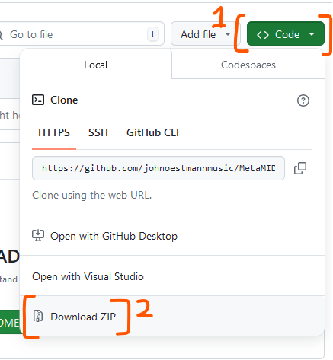

2. Enabling the Harmonix Plugin
To use the MetaMIDI Toolkit, you will need to be using Unreal Engine 5.4 or later, and it needs to support the Harmonix plugin. In Unreal 5.4, this is included with the engine, however it needs to be turned on before you bring in the MetaMIDI files.

Turn this on by:
- Clicking on Settings > Plugins
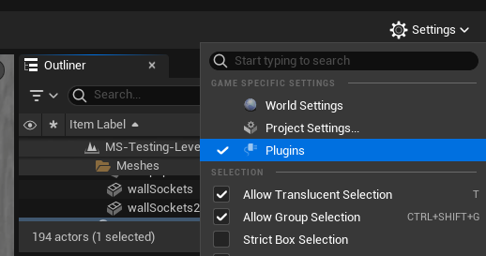

- Searching for “Harmonix”, and turning it on. You may get a warning that it is still an experimental package and can’t be guaranteed to work in all situations.
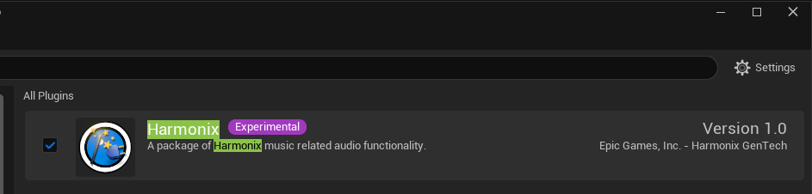

- Once that is ticked, bring the MetaMIDI folder into your project!

3. File Structure
Once you’ve added the MetaMIDI_Toolkit folder to your Unreal Engine project, you will find a number of files and folders inside. These include:
- BP-METAMIDI-Player-Master: This is the Blueprint which you will drag into any scene that you want the MetaMIDI music to play. All of the adjustable Macros will be on this Actor once in your scene. In this same folder is the ‘EmotionListEnum’ file.
This is designed to be customized by the Game Designer.

- MetaSounds/MS-METAMIDI-Player: This is the core Metasounds patch, containing the playback, synthesis, and Macro functionality.
This is designed to be customized by the Composer.

- MetaSounds/MIDI-Files: These are the music MIDI files that are played by the MetaMIDI Toolkit. Each music track in here aligns with one Emotion in this base Toolkit (These have already been converted to ‘uasset’ files, but the original MIDI files can be found in the ‘MetaMIDI_Toolkit-Additional’ folder).
This is where the Composer can change the music files being played.

- MetaSounds/Instruments: This contains instrument synthesis Metasounds patches which are used within MS-METAMIDI-Player.
This is where the Composer can change the core synthesizer functionality.

Playing the Music and Macros
The quickest way to play the music is to drag the BP-METAMIDI-Player-Master object into a scene as an Actor.
If you hit play on the scene, you will hear the MetaMIDI Toolkit playing the music for Emotion-Mad (the default).

Macros
Once it is in your scene, you can click on the Actor and find the MetaMIDI Macro Variables (Macros for short). These are designed to provide a simpler and more intuitive front-end for the Game Designer, but are connected to several musical and technical settings in MS-METAMIDI-Player.

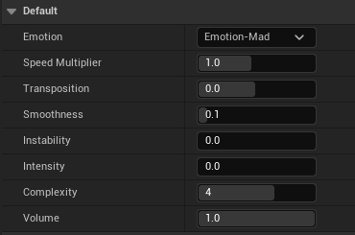

See the next pages for Macro descriptions.
The Macros are as follows:

Macro | Values | Description | Additional Composer’s notes
Emotion | Emotion-Mad,  Emotion-Sad,  Emotion-Sacred  Emotion-Joyful  Emotion-Powerful  Emotion-Peaceful  Default: Emotion-Mad | A dropdown list of 6 base emotions. Each emotion is tied to a different music track. | In this base Toolkit, when the Emotion is changed mid-game, it will load the new MIDI file and then play after a 0.5 second delay. This is to make sure the previous track stops before attempting to play the new one.
Speed Multiplier | 0.1 to 2.0  Default: 1.0 | Changes the speed of the music. | This changes the MIDI playback, and so it doesn’t affect the pitch of the synthesizers.
Transposition | - 12.0 to 12.0  Default: 0.0 | Changes the pitch of the music. | This float value is in semitones, and specifically affects the MIDI Note numbers which are fed into the synthesizers.
Smoothness | 0.0 to 1.0  Default: 0.1 | Changes the length of the notes for a more smooth or stuttery effect. | This changes the Attack and Decay of each note (the included FM Synth uses AD envelopes instead of ADSR).
Instability | 0.0 to 1.0  Default: 0.0 | A higher number makes the played notes sound more out of tune for an uncomfortable effect. | At the full 1.0, the resulting frequency of each note played is skewed by up to + or - 40hz.
Intensity | 0.0 to 1.0  Default: 0.0 | A higher number makes the instruments sound more harsh and intense. | This increases the FM Amount of each of the 3 Operators of the FM Synths by up to 800hz.
Complexity | 0 to 6  Default: 4 | This is the number of instruments that will play.  The default is set to 4 as a good balance.  Higher numbers can push the music towards feeling overwhelming, and lower numbers towards feeling simple. | This actually chooses which MIDI Channels play. E.g. when set to 3, Channels 1 to 3 play. When set to 5, Channels 1 to 5.  The included MIDI music aims to have core harmony on the lower Channels, and flourishes on the higher Channels.
Volume | 0.0 to 1.0  Default: 1.0 | Changes the Volume of the music. | This changes the final volume internally in MS-METAMIDI-Player. This does not affect any volumes set of the audio object elsewhere.

Extending Macros Further
The base MetaMIDI Toolkit provided includes the above functionality. However, this project has been made open-source so that you can customize it as far as you’d like.
It is recommended that the composer and programmers spend some time exploring the Metasounds patches themselves to better understand how the Toolkit may be extended for your project.

Implementing the Player-Reactive Music
While playing with the in-editor Macro sliders can be good for getting a sense of how different settings affect the music in different ways, the true power of this Toolkit comes from connecting the Macros to in-game changes.

For example, you might want the music Speed Multiplier to increase as time is running out in an arcade game. You may want the Intensity to increase as your player gets closer to their enemies. You might want the music to become more Muffled and less Complex as the player goes underwater.

Any combination of these changes are possible, simply by updating the variables inside the BP-METAMIDI-Player-Master Actor.

If you open the Blueprint for BP-METAMIDI-Player-Master, you’ll see that each of the Macro Variables (Smoothness, Intensity, etc) are sent to the Internal Metasounds Macros (e.g. _UI-Smoothness, UI-Intensity, etc) every 0.5 seconds. If you simply add functionality which updates the Macro Variable themselves, the music will update itself for you.

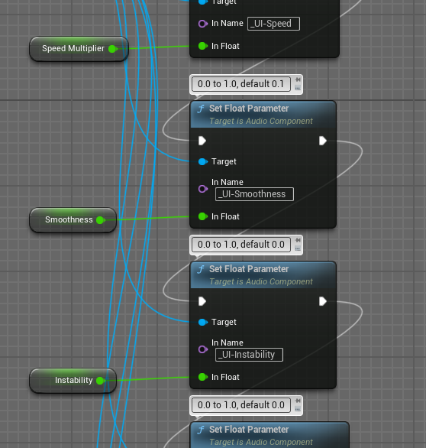
MIT License
Copyright 2024, The University of South Australia
Permission is hereby granted, free of charge, to any person obtaining a copy of this software and associated documentation files (the “Software”), to deal in the Software without restriction, including without limitation the rights to use, copy, modify, merge, publish, distribute, sublicense, and/or sell copies of the Software, and to permit persons to whom the Software is furnished to do so, subject to the following conditions:
The above copyright notice and this permission notice shall be included in all copies or substantial portions of the Software.
THE SOFTWARE IS PROVIDED “AS IS”, WITHOUT WARRANTY OF ANY KIND, EXPRESS OR IMPLIED, INCLUDING BUT NOT LIMITED TO THE WARRANTIES OF MERCHANTABILITY, FITNESS FOR A PARTICULAR PURPOSE AND NONINFRINGEMENT. IN NO EVENT SHALL THE AUTHORS OR COPYRIGHT HOLDERS BE LIABLE FOR ANY CLAIM, DAMAGES OR OTHER LIABILITY, WHETHER IN AN ACTION OF CONTRACT, TORT OR OTHERWISE, ARISING FROM, OUT OF OR IN CONNECTION WITH THE SOFTWARE OR THE USE OR OTHER DEALINGS IN THE SOFTWARE.

